# System testing

## Design of test plan

## VALIDATION TESTING

|  |  |  |  |  |  |
| --- | --- | --- | --- | --- | --- |
| Test No. | page | Purpose of Test | Test Data Used | Expected Outcome | Actual Outcome |
|  | input  customer.asp | check if “first name” does not allow empty field | “ ” | Error message | Error message |
|  | input  customer.asp | check if “last name” does not allow empty field | “ ” | Error message | Error message |
|  | input  customer.asp | check if “address line 1” does not allow empty field | “ ” | Error message | Error message |
|  | input  customer.asp | check if “address line 2” does not allow empty field | “ ” | Error message | Error message |
|  | input  customer.asp | check if “post code” does not allow empty field | “ ” | Error message | Error message |
|  | input  customer.asp | check if “email address” does not allow empty field | “ ” | Error message | Error message |
|  | input  customer.asp | check if “date of birth” does not allow empty field | “ ” | Error message | Error message |
|  | input  customer.asp | check if “contact number” does not allow empty field | “ ” | Error message | Error message |
|  | input  customer.asp | check if “emergency contact number” does not allow empty field | “ ” | Error message | Error message |
|  | input  customer.asp | check if “password” does not allow empty field | “ ” | Error message | Error message |
|  | input  customer.asp | check if “first name” does not allow null field | “ ” | Error message | Error message |
|  | input  customer.asp | check if “last name” does not allow null field | “ ” | Error message | Error message |
|  | input  customer.asp | check if “address line 1” does not allow null field | “ ” | Error message | Error message |
|  | input  customer.asp | check if “address line 2” does not allow null field | “ ” | Error message | Error message |
|  | input  customer.asp | check if “post code” does not allow null field | “ ” | Error message | Error message |
|  | input  customer.asp | check if “email address” does not allow null field | “ ” | Error message | Error message |
|  | input  customer.asp | check if “date of birth” does not allow null field | “ ” | Error message | Error message |
|  | input  customer.asp | check if “contact number” does not allow null field | “ ” | Error message | Error message |
|  | input  customer.asp | check if “emergency contact number” does not allow null field | “ ” | Error message | Error message |
|  | input  customer.asp | check if “password” does not allow null field | “ ” | Error message | Error message |
|  | input  customer.asp | Check if email address contains an “@” | Tw.tw.com | Error message | Error message |
|  | input  customer.asp | Check if email address contains a “.” | “tw@skirossy” | Error message | Error message |
|  | input  customer.asp | Check if length.date of birth is more than 7 char | 22/12 | Error message | Error message |
|  | input  customer.asp | Check if date of birth is less than 10 char | 22/12/2012 | acceptance | acceptance |
|  |  |  |  |  |  |
|  | Bookparty.asp | Check If an activity from the select box is not acceptant of none | No entry | Error message | Error message |
|  | Bookparty.asp | Check that by clicking on the value skiing in the select box for activity, the value skiing is assigned | skiing | Message saying skiing is assigned, | skiing is assigned |
|  | Bookparty.asp | Check that by clicking on the value snowboarding in the select box for activity, the value snowboarding is assigned | snowboarding | Message saying snowboarding is assigned, | snowboarding is assigned |
|  | Bookparty.asp | Check that by clicking on the value tubing in the select box for activity, the value tubing is assigned | tubing | Message saying tubing is assigned, | tubing is assigned |
|  | Bookparty.asp | Check that by clicking on the value tubing in the select box for activity, the select options for skill level become disabled and vice versa | tubing | Error message | Error message |
|  | Bookparty.asp | Check that the form does not allow decision on the skill level select box when tubing selected | Attempt click | Unable to do | Unable to do |
|  | Bookparty.asp | Check that by clicking on the value beginner in the select box for skill level, the value beginner is assigned | beginner | Message saying beginner is assigned, | beginner is assigned |
|  | Bookparty.asp | Check that by clicking on the value intermediate in the select box for skill level, the value intermediate is assigned | intermediate | Message saying intermediate is assigned, | intermediate is assigned |
|  | Bookparty.asp | Check that by clicking on the value advanced in the select box for skill level, the value advanced is assigned | advanced | Message saying advanced is assigned, | advanced is assigned |
|  | Bookparty.asp | Check if number of adults and number of infants and number of children and number of teens do not accept all equalling 0 | 0,0,0,0 | Error message | Error message |
|  | Bookparty.asp | Check if date does not allow empty field | “ ” | Error message | Error message |
|  | Bookparty.asp | Check if date does not allow null field | “ ” | Error message | Error message |
|  | Bookparty.asp | Check if date input only accepts dates in the format of (D,DD)/(M,MM)/YYYY by entering a value of format DD/MM/YY | 21/12/14 | Error message | Error message |
|  | Bookparty.asp | Check if date input only accepts dates in the format of (D,DD)/(M,MM)/YYYY by entering a value of format D/MM/YY | 2/12/14 | Error message | Error message |
|  | Bookparty.asp | Check if date input only accepts dates in the format of (D,DD)/(M,MM)/YYYY by entering a value of format DD/M/YY | 12/3/14 | Error message | Error message |
|  | Bookparty.asp | Check if date input only accepts dates in the format of (D,DD)/(M,MM)/YYYY by entering a value of format D/M/YY | 1/1/14 | Error message | Error message |
|  | Bookparty.asp | Check if date input only accepts dates in the format of (D,DD)/(M,MM)/YYYY by entering a value of format DD/MM/YYYY | 21/12/2014 | ACCEPT | ACCEPTED |
|  | Bookparty.asp | Check if date input only accepts dates in the format of (D,DD)/(M,MM)/YYY by entering a value of format D/MM/YYYY | 1/12/2014 | ACCEPT | ACCEPTED |
|  | Bookparty.asp | Check if date input only accepts dates in the format of (D,DD)/(M,MM)/YYY by entering a value of format DD/M/YYYY | 22/1/2014 | ACCEPT | ACCEPTED |
|  | Bookparty.asp | Check if date input only accepts dates in the format of (D,DD)/(M,MM)/YYY by entering a value of format D/M/YYYY | 3/1/2014 | ACCEPT | ACCEPTED |
|  | Bookparty.asp | Checking if the date input only accepts future dates by entering a date from the past() | 1/1/2012 | Error message | Error message |
|  | Bookparty.asp | Checking if the date input only accepts future dates by entering a borderline date from the past(current date) | Current date at time of test | Error message | Error message |
|  | Bookparty.asp | Checking the stated time for the course can only be on the hour by entering a time that is not on the hour | 12:04 | Error message | Error message |
|  | Bookparty.asp | Ensuring the time input only accepts times between 12:00 and 17:00 by entering 11:00 | 11:00 | Error message | Error message |
|  | Bookparty.asp | Ensuring the time input only accepts times between 12:00 and 17:00 by entering 18:00 | 18:00 | Error message | Error message |
|  | Updatecust  Details.asp | check if “first name” does not allow empty field | “ ” | Error message | Error message |
|  | Updatecust  Details.asp | check if “last name” does not allow empty field | “ ” | Error message | Error message |
|  | Updatecust  Details.asp | check if “address line 1” does not allow empty field | “ ” | Error message | Error message |
|  | Updatecust  Details.asp | check if “address line 2” does not allow empty field | “ ” | Error message | Error message |
|  | Updatecust  Details.asp | check if “post code” does not allow empty field | “ ” | Error message | Error message |
|  | Updatecust  Details.asp | check if “email address” does not allow empty field | “ ” | Error message | Error message |
|  | Updatecust  Details.asp | check if “date of birth” does not allow empty field | “ ” | Error message | Error message |
|  | Updatecust  Details.asp | check if “contact number” does not allow empty field | “ ” | Error message | Error message |
|  | Updatecust  Details.asp | check if “emergency contact number” does not allow empty field | “ ” | Error message | Error message |
|  | Updatecust  Details.asp | check if “password” does not allow empty field | “ ” | Error message | Error message |
|  | Updatecust  Details.asp | check if “first name” does not allow null field | “ ” | Error message | Error message |
|  | Updatecust  Details.asp | check if “last name” does not allow null field | “ ” | Error message | Error message |
|  | Updatecust  Details.asp | check if “address line 1” does not allow null field | “ ” | Error message | Error message |
|  | Updatecust  Details.asp | check if “address line 2” does not allow null field | “ ” | Error message | Error message |
|  | Updatecust  Details.asp | check if “post code” does not allow null field | “ ” | Error message | Error message |
|  | Updatecust  Details.asp | check if “email address” does not allow null field | “ ” | Error message | Error message |
|  | Updatecust  Details.asp | check if “date of birth” does not allow null field | “ ” | Error message | Error message |
|  | Updatecust  Details.asp | check if “contact number” does not allow null field | “ ” | Error message | Error message |
|  | Updatecust  Details.asp | check if “emergency contact number” does not allow null field | “ ” | Error message | Error message |
|  | Updatecust  Details.asp | check if “password” does not allow null field | “ ” | Error message | Error message |
|  | Updatecust  Details.asp | Check if email address contains an “@” | Tw.tw.com | Error message | Error message |
|  | Updatecust  Details.asp | Check if email address contains a “.” | “tw@skirossy” | Error message | Error message |
|  | Updatecust  Details.asp | Check if length.date of birth is more than 7 char | 22/12 | Error message | Error message |
|  | Updatecust  Details.asp | Check if date of birth is less than 10 char | 22/12/2012 | ACCEPT | ACCEPTED |
|  | Bookpriv.asp | Check If an activity from the select box is not acceptant of none | None | Error message | Error message |
|  | Bookpriv.asp | Check that by clicking on the value skiing in the select box for activity, the value skiing is assigned | Skiing | Message saying Skiing is assigned, | Skiing is assigned |
|  | Bookpriv.asp | Check that by clicking on the value snowboarding in the select box for activity, the value snowboarding is assigned | Snowboarding | Message saying Snowboarding is assigned, | Snowboarding is assigned |
|  | Bookpriv.asp | Check that by clicking on the value beginner in the select box for skill level, the value beginner is assigned | Beginner | Message saying Beginner is assigned, | Beginner is assigned |
|  | Bookpriv.asp | Check that by clicking on the value intermediate in the select box for skill level, the value intermediate is assigned | Intermediate | Message saying Intermediate is assigned, | Intermediate is assigned |
|  | Bookpriv.asp | Check that by clicking on the value advanced in the select box for skill level, the value advanced is assigned | advanced | Message saying advanced is assigned, | advanced is assigned |
|  | Bookpriv.asp | Check that age is entered and will not accept an empty value | None | Error message | Error message |
|  | Bookpriv.asp | Checking that age will not accept a null value | Null | Error message | Error message |
|  | Bookpriv.asp | Check if date does not allow empty field | “ ” | Error message | Error message |
|  | Bookpriv.asp | Check if date does not allow null field | “ ” | Error message | Error message |
|  | Bookpriv.asp | Check if date input only accepts dates in the format of (D,DD)/(M,MM)/YYYY by entering a value of format DD/MM/YY | 21/12/14 | Error message | Error message |
|  | Bookpriv.asp | Check if date input only accepts dates in the format of (D,DD)/(M,MM)/YYYY by entering a value of format D/MM/YY | 2/12/14 | Error message | Error message |
|  | Bookpriv.asp | Check if date input only accepts dates in the format of (D,DD)/(M,MM)/YYYY by entering a value of format DD/M/YY | 12/3/14 | Error message | Error message |
|  | Bookpriv.asp | Check if date input only accepts dates in the format of (D,DD)/(M,MM)/YYYY by entering a value of format D/M/YY | 1/1/14 | Error message | Error message |
|  | Bookpriv.asp | Check if date input only accepts dates in the format of (D,DD)/(M,MM)/YYYY by entering a value of format DD/MM/YYYY | 21/12/2014 | ACCEPT | ACCEPTED |
|  | Bookpriv.asp | Check if date input only accepts dates in the format of (D,DD)/(M,MM)/YYYY by entering a value of format D/MM/YYYY | 1/12/2014 | ACCEPT | ACCEPTED |
|  | Bookpriv.asp | Check if date input only accepts dates in the format of (D,DD)/(M,MM)/YYYY by entering a value of format DD/M/YYYY | 22/1/2014 | ACCEPT | ACCEPTED |
|  | Bookpriv.asp | Check if date input only accepts dates in the format of (D,DD)/(M,MM)/YYYY by entering a value of format D/M/YYYY | 3/1/2014 | ACCEPT | ACCEPTED |
|  | Bookpriv.asp | Checking if the date input only accepts future dates by entering a date from the past(1/1/2012) | 1/1/2012 | Error message | Error message |
|  | Bookpriv.asp | Checking if the date input only accepts future dates by entering a borderline date from the past(current date) | Current date at time of test | Error message | Error message |
|  | Bookpriv.asp | Checking the stated time for the course can only be on the hour by entering a time that is not on the hour | 12:04 | Error message | Error message |
|  | Bookpriv.asp | Ensuring the time input only accepts times between 12:00 and 17:00 by entering 11:00 | 11:00 | Error message | Error message |
|  | Bookpriv.asp | Ensuring the time input only accepts times between 12:00 and 17:00 by entering 18:00 | 18:00 | Error message | Error message |
|  | Showgroup.asp | check if “courseno” does not allow empty field | “ ” | Error message | Error message |
|  | Showgroup.asp | check if “courseno” does not allow empty field | “ ” | Error message | Error message |

## TESTING RESULTS(validation)

21. 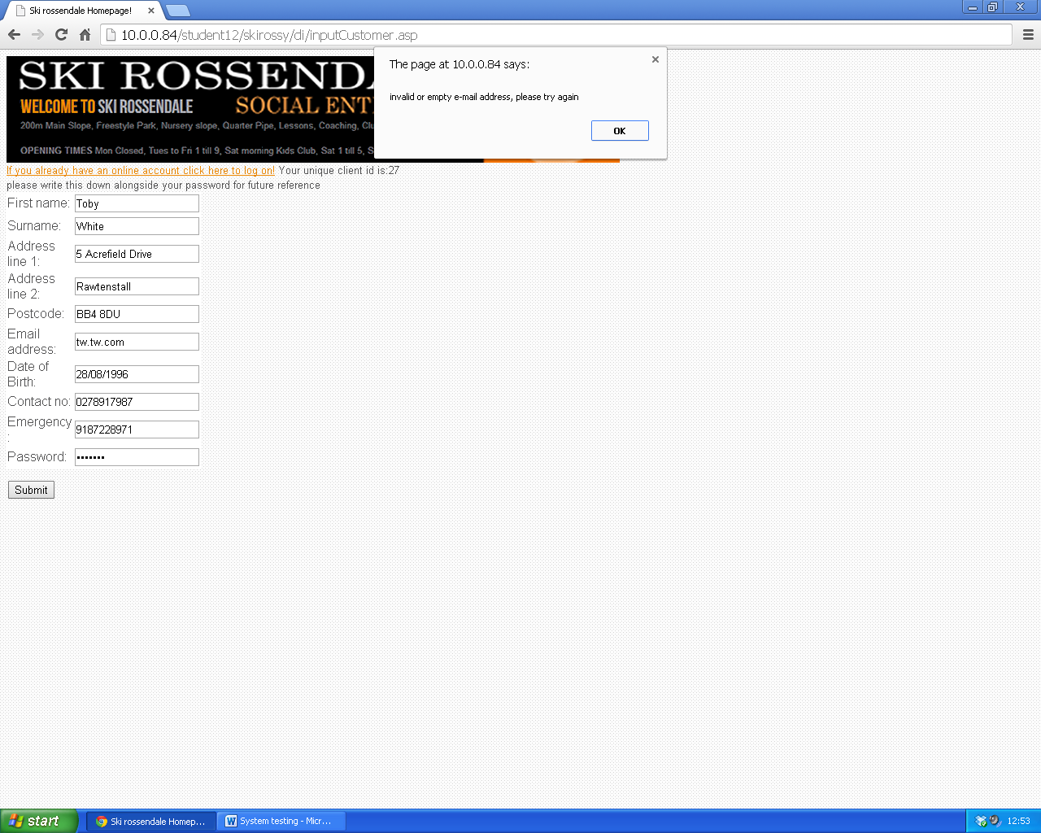

Error message recieved

30. 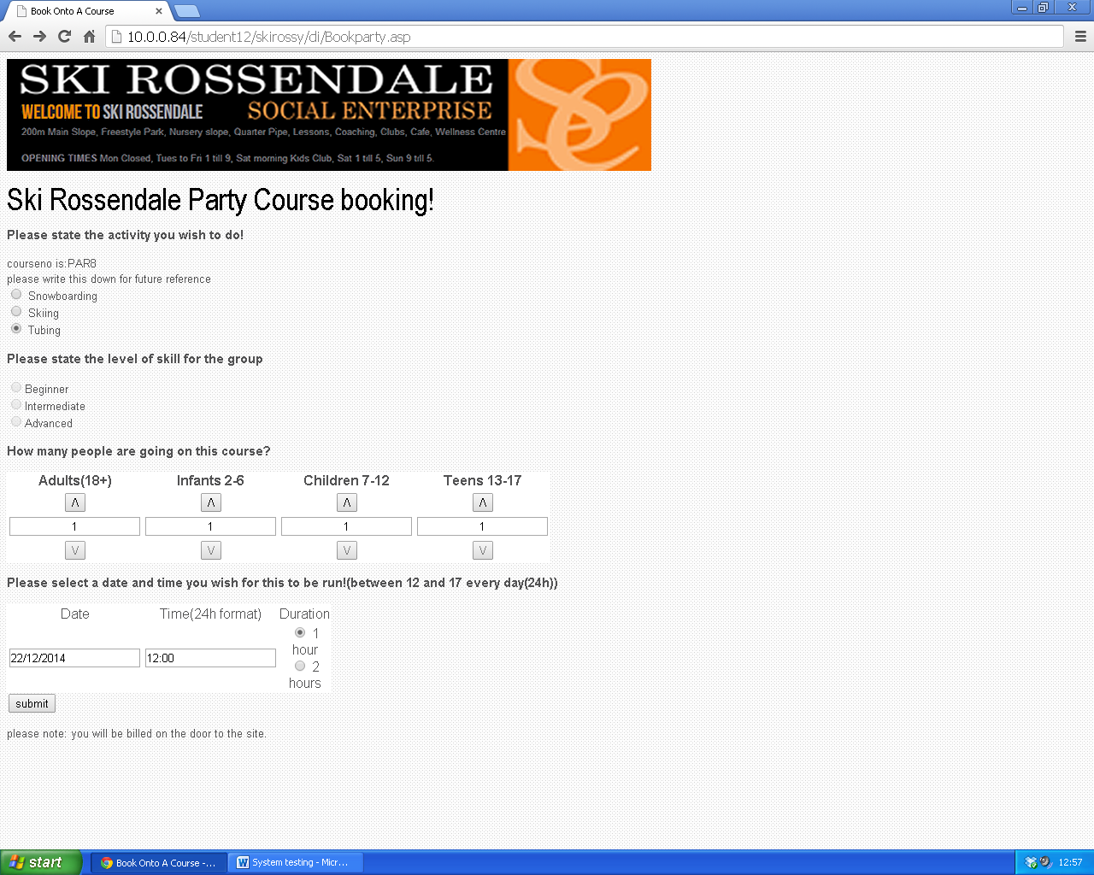

As expected, this option is disabled

34. 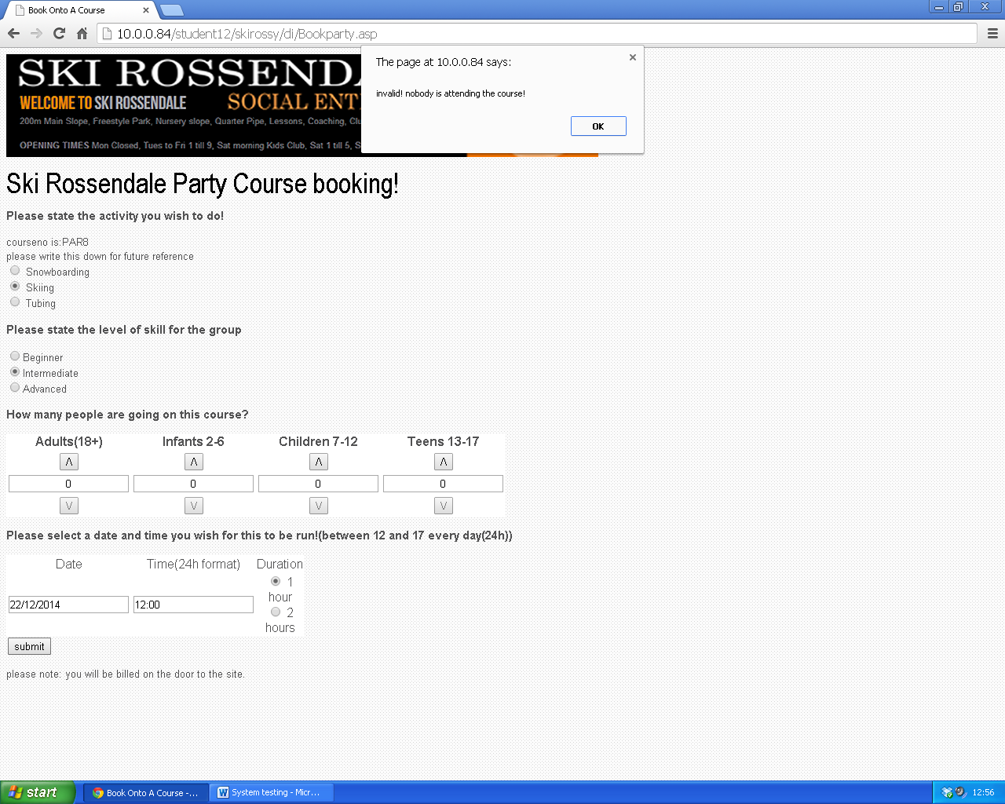

Error message is received

53.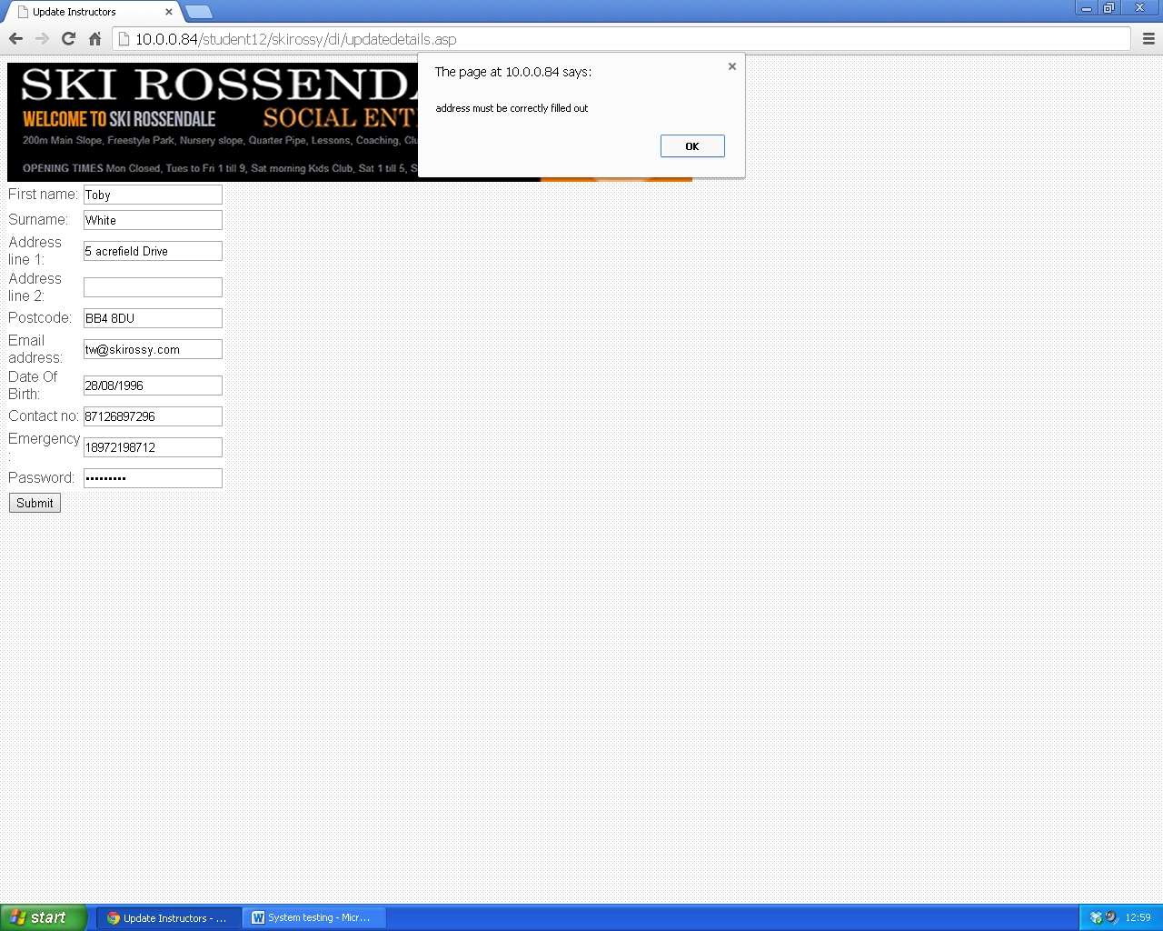

Error message is received

84. 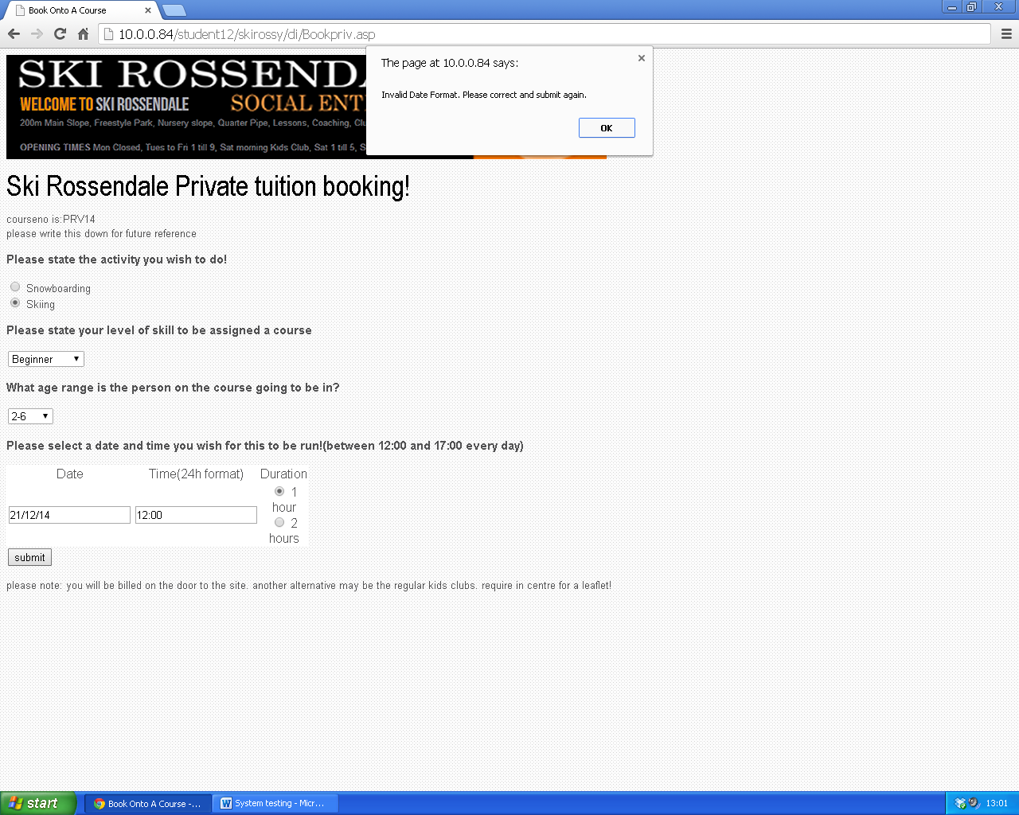

Error message is recieved

98.

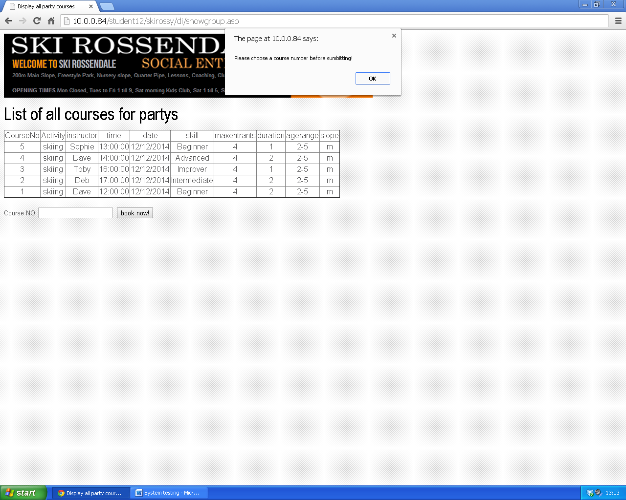

Error message is recieved

## DATA SET TESTING

|  |  |  |  |  |  |
| --- | --- | --- | --- | --- | --- |
| Test No. | Page | Purpose of Test | Test Data Used | Expected Outcome | Actual Outcome |
|  | Showgroup.asp | To check that the correct courses to be listed in the table are retrieved when an the activity skiing is entered into the search screen on bookgroup.asp | Tblgroup  Value chosen-skiing | Only skiing courses shown  And NOT COURSES THAT ARE FULY BOOKED | correct |
|  | Showgroup.asp | To check that the correct courses to be listed in the table are retrieved when an the activity skiing is entered into the search screen on bookgroup.asp | Tblgroup  Value chosen-  snowboarding | Only snowboarding courses shown  And NOT COURSES THAT ARE FULY BOOKED | Correct |
|  | Searchcustomerdetails.asp | To check that the correct customer details are retrieved when the customer id is entered into the search screen. | Tblcustomer  Id chosen-24 | Firstname-Toby  Lastname-White  Adressln1-5 acrefield drive  Adressln2-reedsholme  Postcode-bb4 8du  [Email-toby@skirossendale.co.uk](mailto:Email-toby@skirossendale.co.uk)  Dob-28/08/1996  Phoneno-07826852610  Emergency-01706312052  Password-toby | Correct |
|  | Searchprivcoruse.asp | To check that the correct instructor led are retrieved when the instructor id is entered into the search screen. | Tblprivate-  Instructor-toby | Courseno-3  Clientid-1  Activity-snowboarding  Instructor-toby  Skill-improver  Date-12/07/2013  Time-11:00  Duration-1  Agerange-2  Slope-fp | Correct |
|  | Searchprivcoruse.asp | To check that the correct course lists are retrieved when the activity is entered into the search screen. | Tblprivate-  Activity=skiing | Sample list-  Courseno-1  Clientid-22  Activity-skiing  Instructor-dave  Skill-beginner  Date-25/10/2013  Time-11:00  Duration-1  Agerange-2  Slope-m  **Must display a list of all courses as long as the activity for all of them are listed as activity=skiing** | Correct |
|  | Searchprivcoruse.asp | To check that the correct customer details are retrieved when the customer id is entered into the search screen. | Tblprivate-  Customerid-25 | Courseno-6  Clientid-25  Activity-snowboard  Instructor-dave  Skill-intermediate  Date-12/01/2013  Time-11:00  Duration-1  Agerange-2  Slope-m  **Will display all courses the user** correct **has, is ok as long as all have the correct id** | correct |
|  | Searchprivcoruse.asp | To check that the correct course information between the set dates are retrieved when two dates are entered into the search screen. | Tblprivate-  Date1=12/07/2013  Date2=12/11/2014 | Courseno-13  Clientid-25  Activity-skiing  Instructor-toby  Skill-beginner  Date-12/11/2014  Time-12:00  Duration-1  Agerange-2  Slope-m | Correct |
|  | Searchparty.asp | To check that the correct course lists are retrieved when the activity is entered into the search screen. | Tblparty-  Activity=tubing | Courseno-6  Clientid-24  activity-tubing  skill-n/a  numberadults-1  numberinfants-3  numberchildren-1  numberteens-0  date-09/10/2013  time-12:00  duration-2  slope-m | Correct |
|  | Searchparty.asp | To check that the correct customer details are retrieved when the customer id is entered into the search screen. | Tblparty-  clientid=23 | Courseno-4  Clientid-23  activity-snowboarding  skill-beginner  numberadults-0  numberinfants-2  numberchildren-1  numberteens-1  date-20/02/2014  time-14:00  duration-2  slope-b | Correct |
|  | Searchparty.asp | To check that the correct course information between the set dates are retrieved when two dates are entered into the search screen. | Tblparty-  Date1=12/11/2013  Date2=12/07/2014 | AS AN EXAMPLE-  Courseno-4  Clientid-23  activity-snowboarding  skill-beginner  numberadults-0  numberinfants-2  numberchildren-1  numberteens-1  date-20/02/2014  time-14:00  duration-2  slope-b | Correct |

## Test results(data sets)

1. 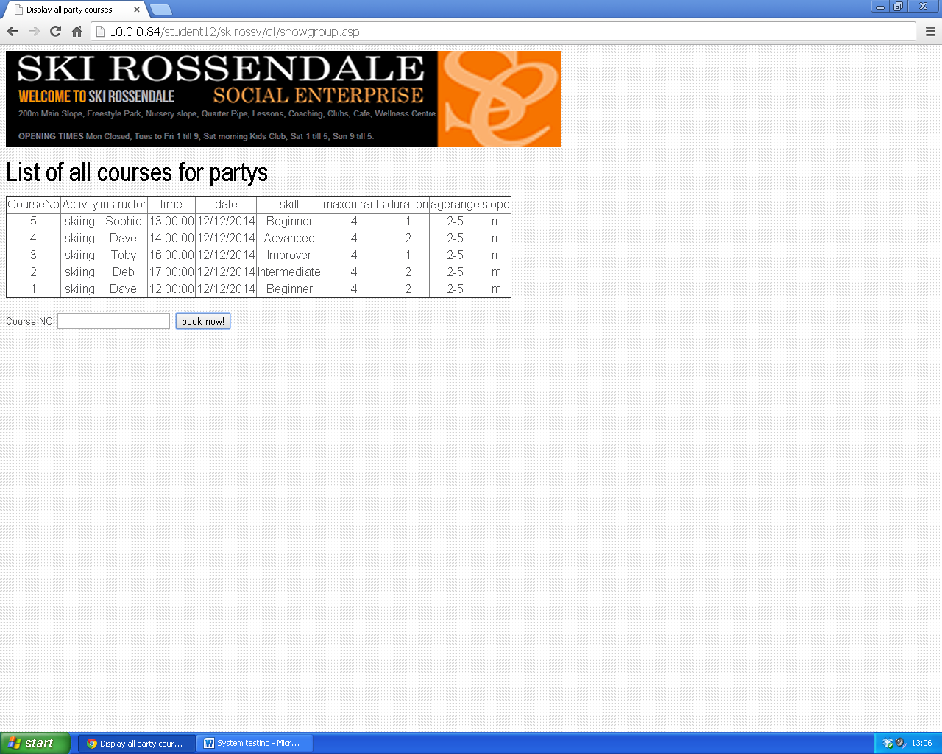

Correct results are returned.

2.

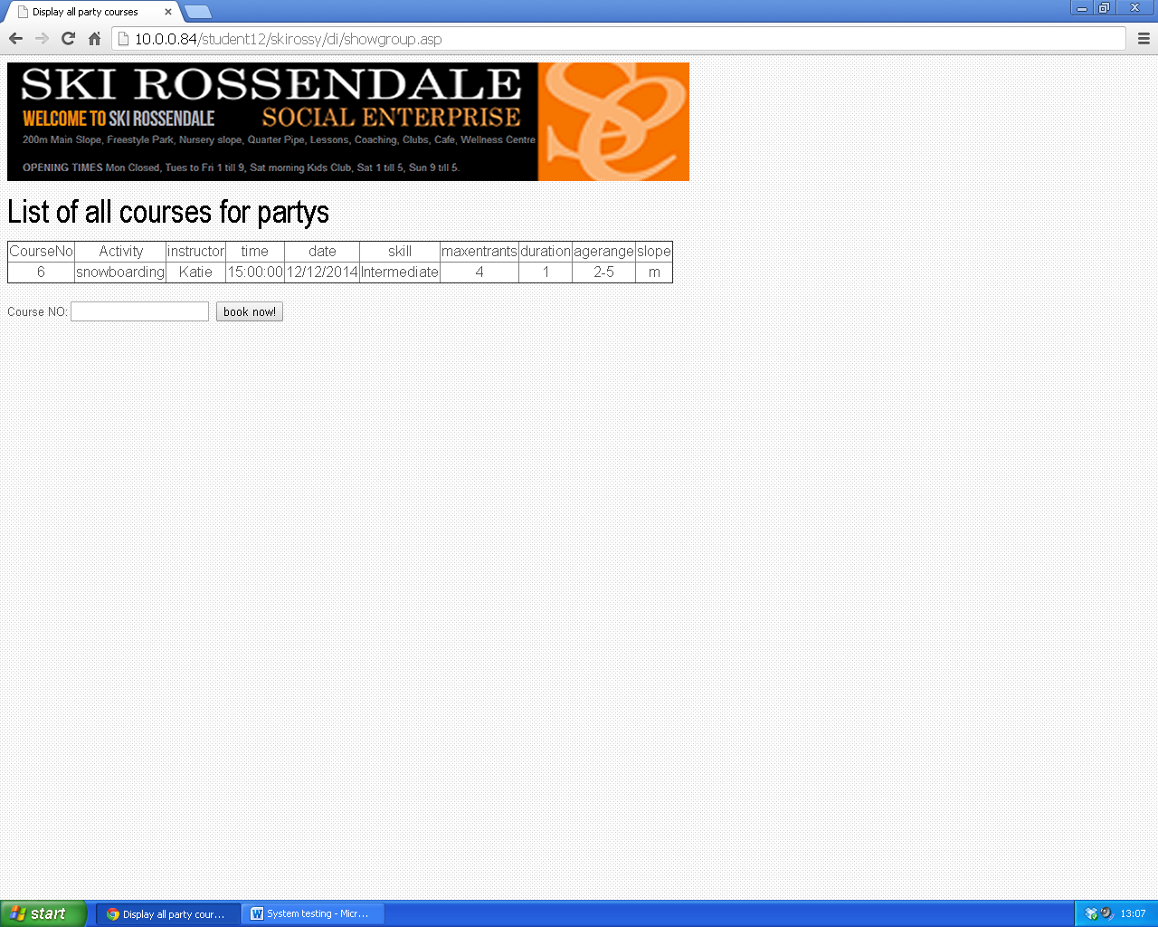

Correct results are returned.

3.

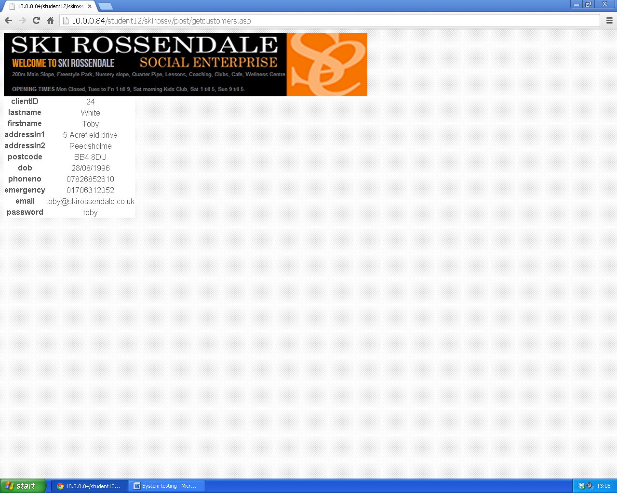

Correct results are returned.

4.

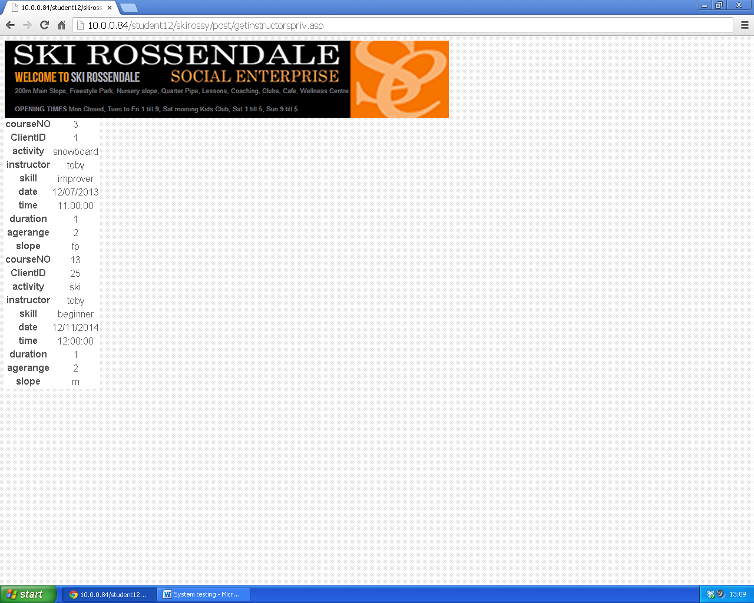

Correct results are returned.

5.

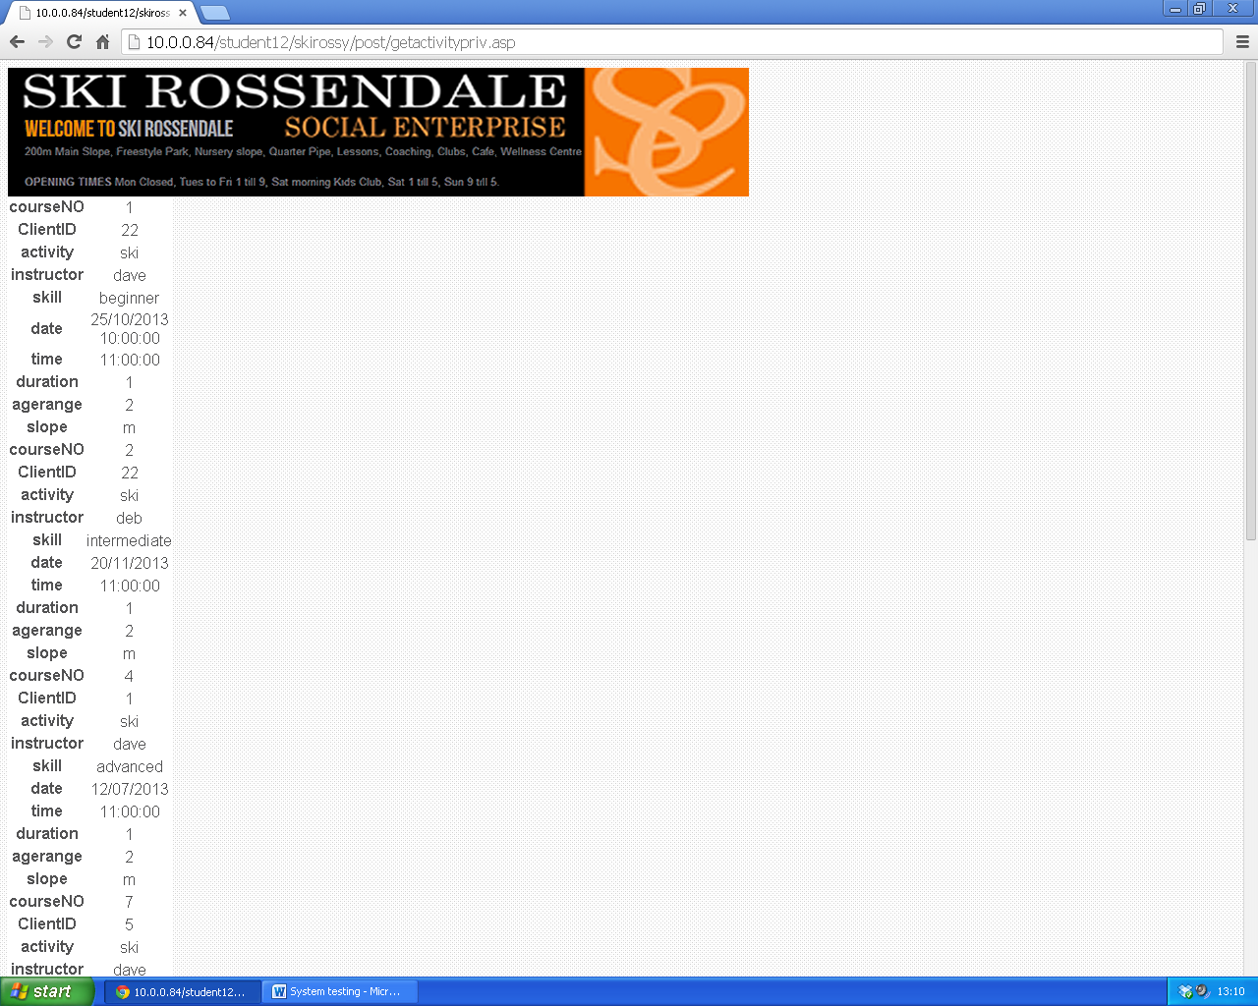

Correct results are returned.

6.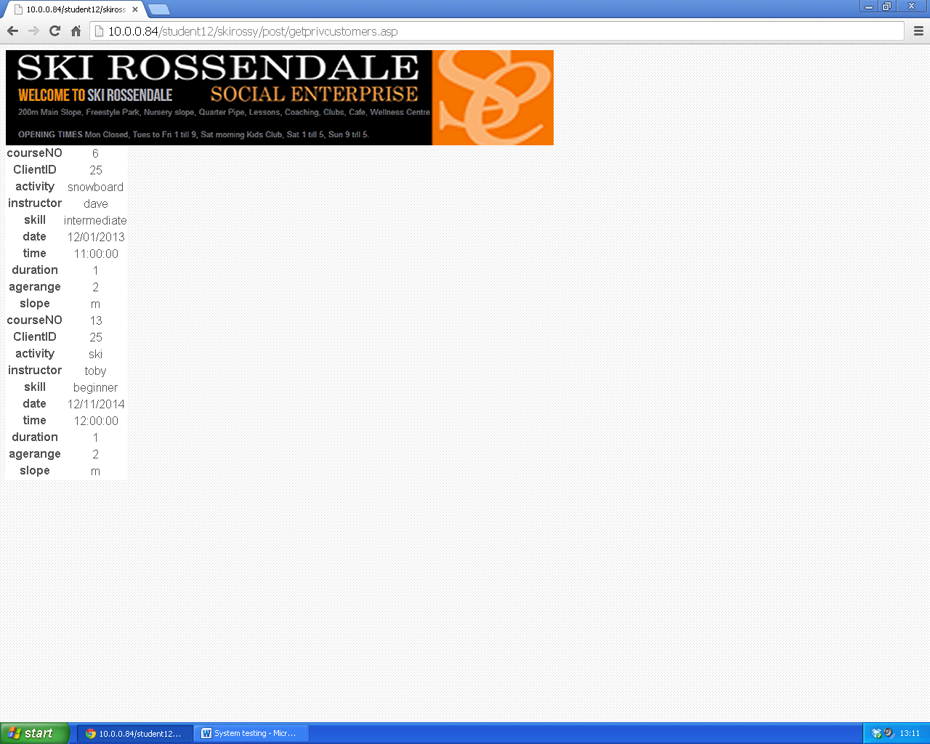

Correct results are returned.

7.

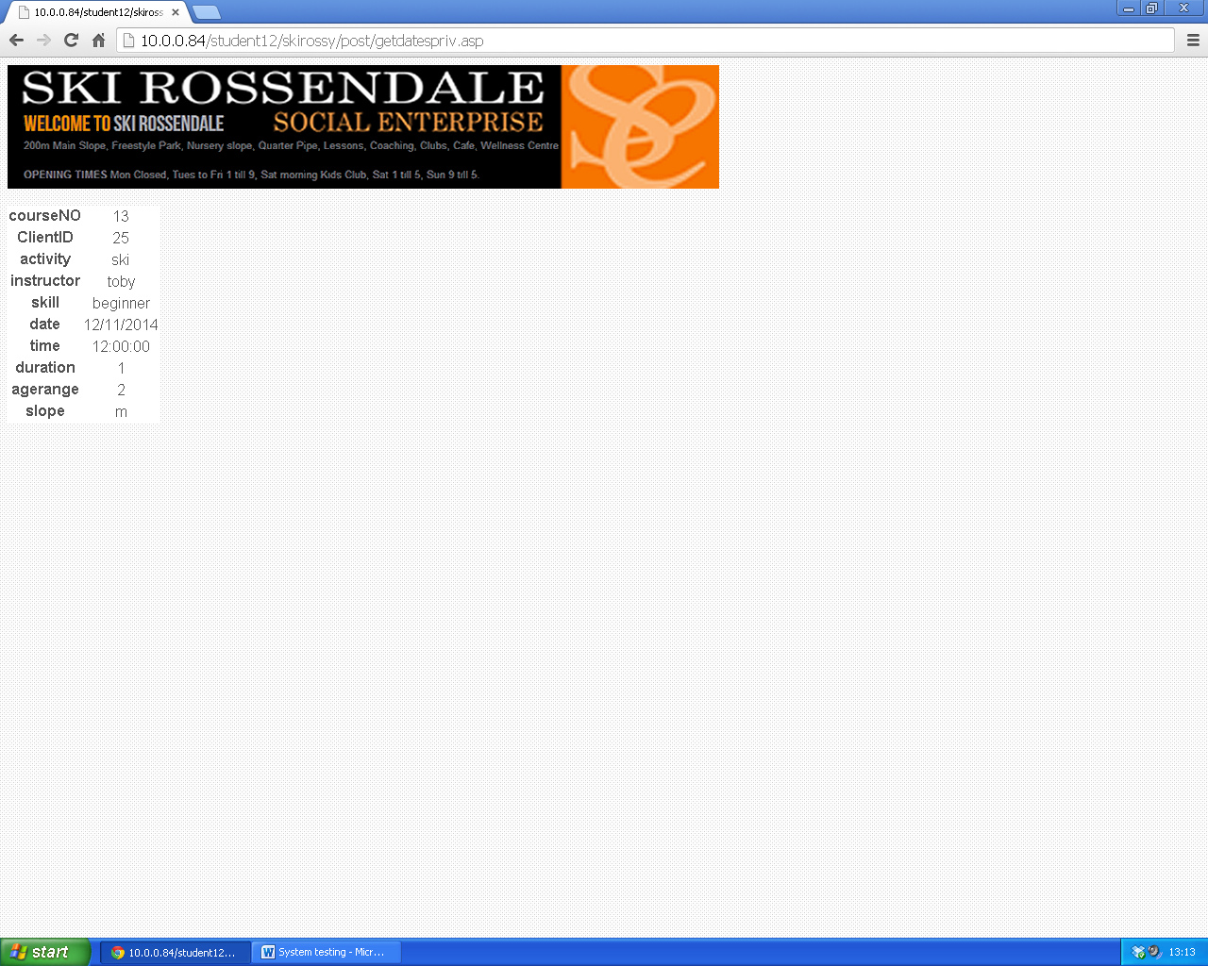

Correct results are returned.

8.

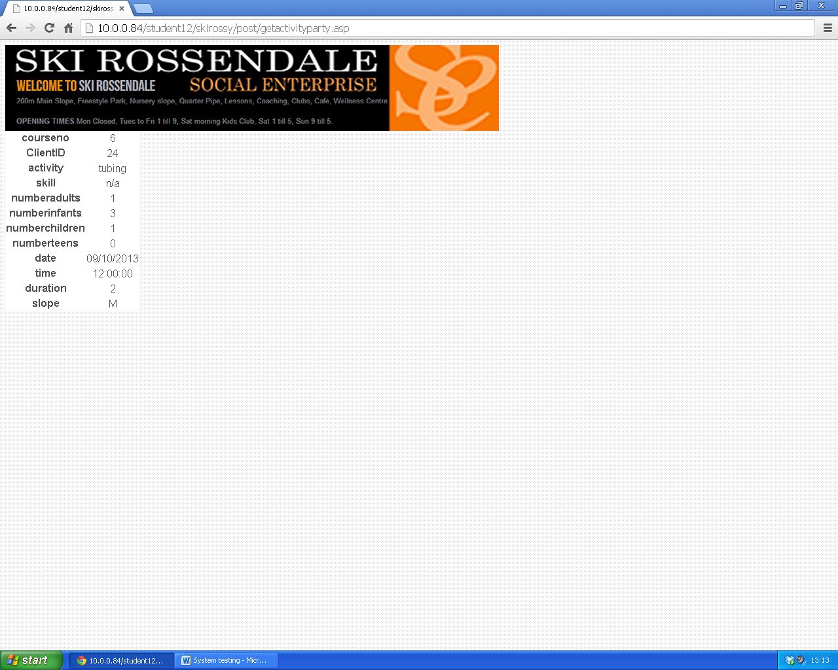

Correct results are returned.

9. 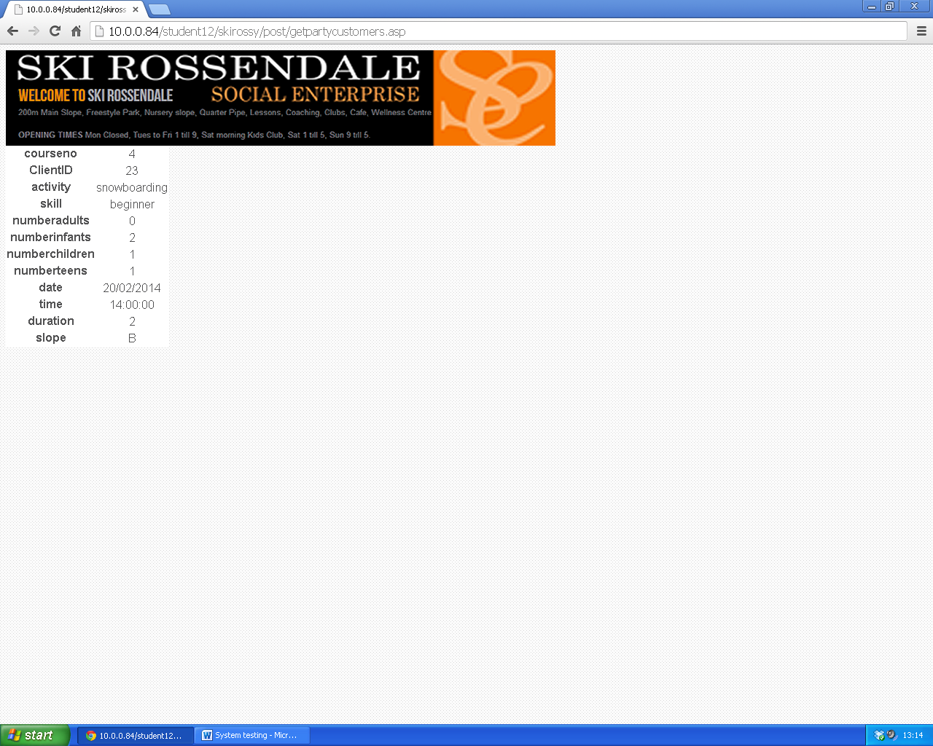

Correct results are returned.

10.

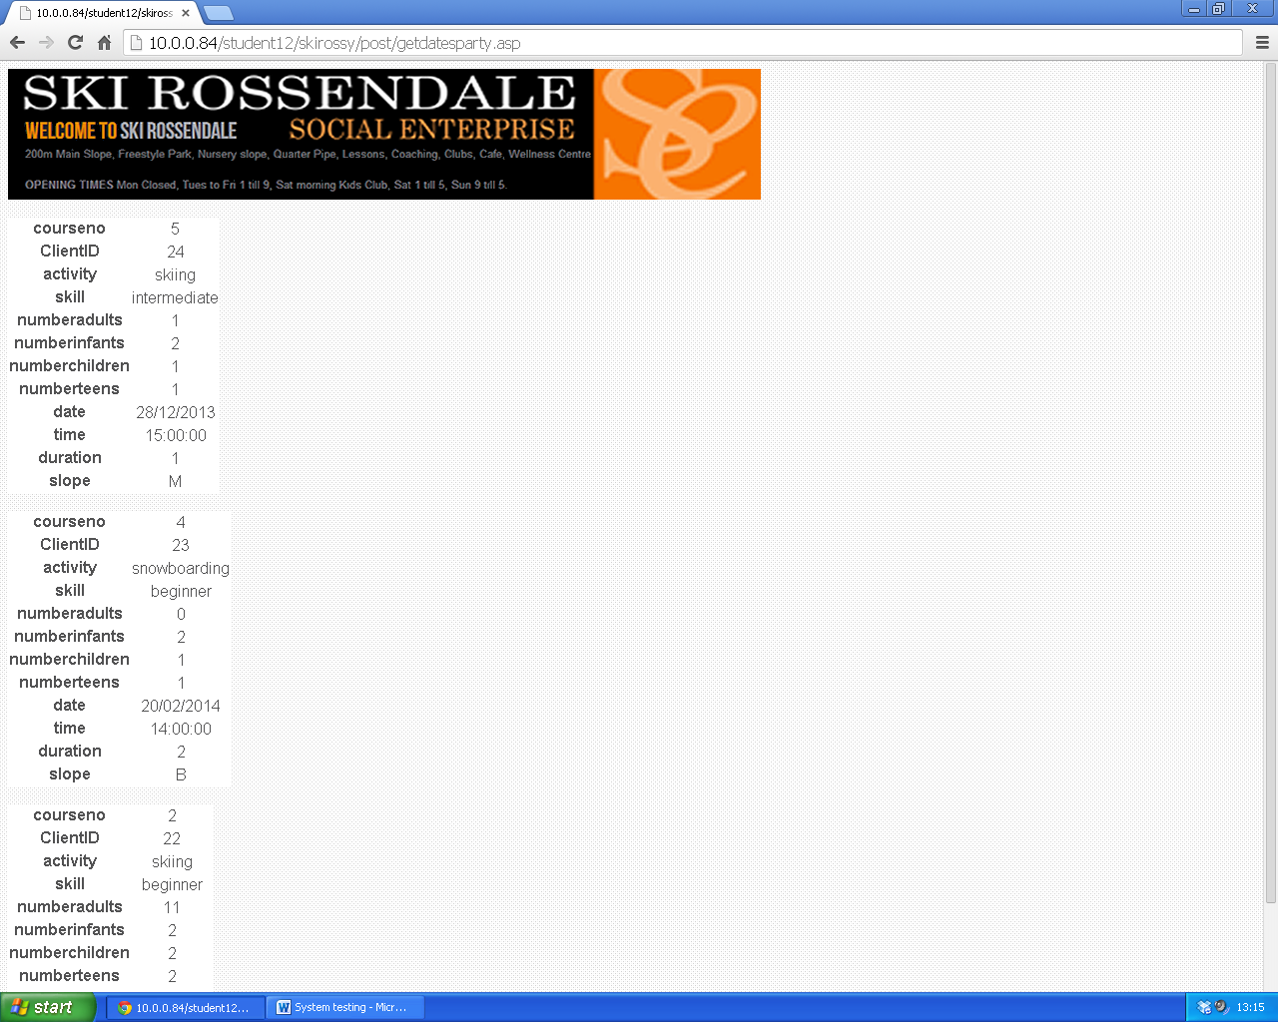

Correct results are returned.